Movement Based Classification of Autism Spectrum Disorder In Children Using Catboost

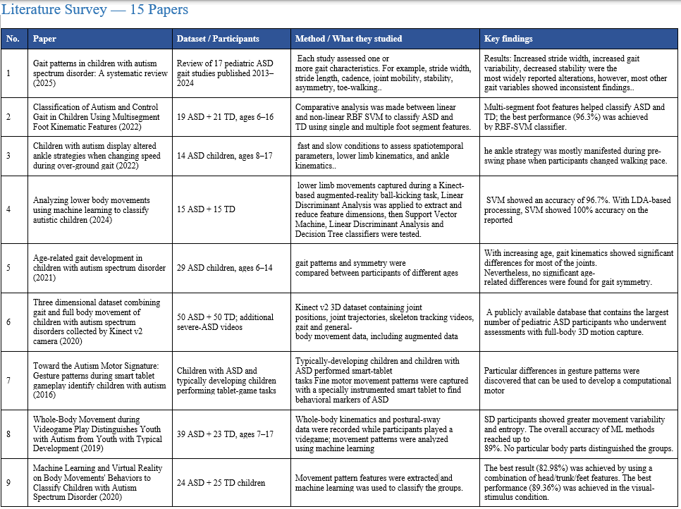
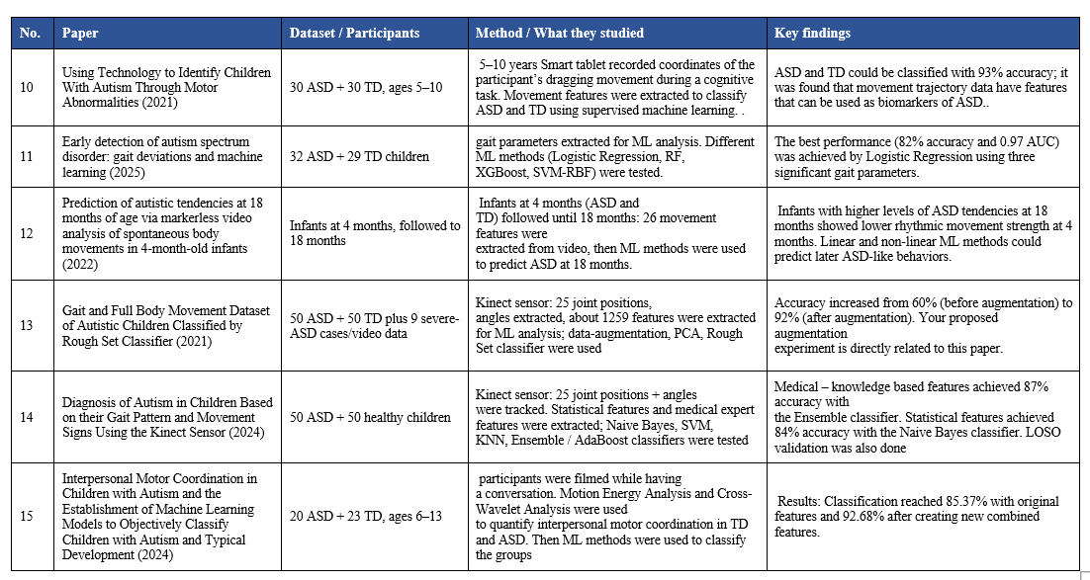
Important Paper Links
- 2025 Systematic Review — Gait patterns in children with ASD: https://www.sciencedirect.com/science/article/pii/S266633762500112X
- 2022 — Classification of Autism and Control Gait in Children: https://www.mdpi.com/2306-5354/9/10/552
- 2022 — Children with autism display altered ankle strategies: https://www.sciencedirect.com/science/article/pii/S0268003322002340
- 2024 — Lower-body movement + machine learning classification: https://www.sciencedirect.com/science/article/pii/S174680942400346X
- 2021 — Age-related gait development in ASD: https://www.sciencedirect.com/science/article/pii/S0966636220306895

GAP IDENTIFIED
- Previous studies showed that there is a difference in body movement between children with ASD and typically developing children.
- The studies use different data set, evaluation methods, and movement features and many have relatively small number of children
- The generalization to unseen children remains an important issue here, so our study specifically evaluates it by making child level movement profile and using a different algorithm.

Problem Statement
To develop a movement-based ASD classification model and evaluate how well it generalizes to completely unseen children by doing strict child-level testing.

Objectives
- Data Processing and Feature Engineering before we feed the data into a model, the raw 3D skeleton data(joint coordinates) must be transformed into meaningful movement metrics.
- Creating a child level profile creation because our objective is not only to develop a model to classify ASD but also to do strict child-level separation, so we cannot feed raw frame by frame data directly into the model.
- Develop an ASD-TD classification model using CatBoost
Proposed Methodology
- Data Collection/Dataset: our dataset contains body movement of 50ASD and 50 TD children
- Preprocessing: Cleaning the data checking inconsistent values, missing values needed to be removed transforming data into numerical features
- Creating a child level Movement profile which will contain joint coordinates for a particular child in the form of frames
- Catboost: We are using catboost because final movement profile will form a tabular dataset containing multiple numerical features.
- Evaluating the model by testing it on completely unseen children using strict child-level separation. Catboost is good at finding complex patterns between feature also works well with missing values.
- Training methodology: strict child level splitting
- Evaluation metrics: Accuracy, precision, F1-score, Recall
- Result Anlaysis.

ABSTRACT
Autism Spectrum Disorder (ASD) is neurodevelopmental disorder that is maybe associated with the body movement or motor functions of a child. These children show difference in body movement then a typical developing child. Our project aim to study this difference in body movement and to check whether body movement contains useful information related to ASD, but this is not the only main motive of the study. Our study is strictly limited to children not adults. The dataset we are using consists of 50 children with ASD + 50 typically developing children. The dataset includes body-joint positions, distance – relationship between joints and range of motions. Our research focus is to study how well the model generalizes to completely unseen children as well. Meaning if the model learns from some children will it work on completely new children when the model has never seen. The training and testing sets will have completely different children. Then we will see the result and see what the results are and how well the model works when working with unseen data.

Introduction
Autism spectrum disorder is neurodevelopmental disorder whose behavioral manifestations increasingly involve disrupted motor control and affects other body movements as well . Because of this the body movements of a children can be used to classify or distinguish children with ASD and normal children, and this is what our area of study is focused on.

Literature Survey
Gait patterns in children with autism spectrum disorder:
The study reviewed gait patterns in children with ASD and their movement range and
Identified differences in walking characteristics when compared to a typically developing child.
It shows gait patterns can be used for ASD analysis.
Drawback:
the major drawbacks that were pointed out in the literature review is small sample sizes, different methodologies used, and different participants. Furthermore, there are still no clear findings regarding some parameters of gait like stride length, symmetry, and joint mobility. We cannot draw a clear conclusion on the basis of the studies included in the review because of the differences in methodologies and participants in these studies
Classification of Autism and Control Gait in Children Using Multisegment Foot Kinematic Features:
The study employed kinematics of the multisegment foot to determine differences in gait among children with autism spectrum disorder and typically developed children. Different movement features were obtained from various foot segments and used for classification using machine learning techniques. The findings revealed that multisegment foot kinematic features can be used to discriminate ASD.
Drawback:
The experiment was carried out on a small sample of children using a controlled laboratory setting. The analysis mainly focused on the kinematics of multi-segment foot. The authors proposed the use of larger data sets and more features. Hence, it is not clear how well the model generalizes to new children.
Children with autism display altered ankle strategies when changing speed during over-ground gait:
The study reviewed ankle movement of various children having ASD then this ankle movements were compared with the ankle movement of typically developing children while changing the walking speed. Difference in ankle movement and strategies were observed in both the groups.
Drawback:
The study was done on a small number of children and focused mainly on ankle movement at different walking speeds. The main focus of this study was to study ankle movement difference rather than developing a general ASD classification model. Therefore the findings do not proof that movement patterns can classify an unseen children.
Analyzing lower body movements using machine learning to classify autistic children:
The lower limb movements of the subjects were analyzed in the experiment, and movement features were extracted for ASD classification. Machine learning algorithms were used on the extracted features to classify children with ASD from those who were normally developed. This study demonstrated that there is valuable information available in lower limb movement for classification purposes.
Drawback:
This research was centered around an interactive task. In this research, attention was paid to lower body movements rather than the entire body. This research does not help identify the type of Autism Spectrum Disorder. This research needs to take into consideration all body movements. Due to the specific design of the task, further research is required.
Age-related gait development in children with autism spectrum disorder:
They study focused on how with age the gait characteristics develops differently in children with ASD in comparison to typically developing children. The researchers used various spatiotemporal and kinematic gait parameters to study age related changes in walking patterns.
Drawback:
It should be noted that the study concentrated on the developmental aspects for the children with ASD, but not the classification itself. Moreover, the research was conducted for children with mild ASD only. Age might have some impact on the gait and thus on the classification as well.
dimensional dataset combining gait and full body movement of children with autism spectrum disorders collected by Kinect v2 camera (2020) :
This study utilized data set with gait and full body motion features for children with ASD. The Rough Set Classifier was used to find patterns that would help separate children with autism from typically developed children. Data augmentation was used to enlarge the dataset.
Drawback:
The dataset comprises gait data as well as the whole-body motion data and even data augmentation is employed to increase the number of samples. However, with an increase in the number of samples, there is no increase in the number of independent children. This makes the paper have no indication of the model's performance on new children.
The Autism Motor Signature: Gesture patterns during smart tablet gameplay identify children with autism (2016) :
The study used a tablet gameplay to study how the children movement, touching pressure and gestures differ and how the interaction patterns are different between the children with ASD and typically developing children.
Drawback:
This study used an unique activity in tablet games and a fairly small sample group. Other participant characteristics like intelligence and the basis for their selection could have an impact on their movements as well. The authors recommend a need for more and varied samples. This makes it a challenge to generalize to other children.
Body Movement during Videogame Play Distinguishes Youth with Autism from Youth with Typical Development (2019) :
In this study whole body movement of both children with ASD and typically developing children were recorded using motion-tracking technology. It was found that the movement pattern of ASD child and TD child is different and suggested that whole body movement characteristics are useful for ASD classification.
Drawback:
There was a relatively small sample size in the study, which could pose limitations in terms of generalizing the results to other children.
Children were monitored while they were playing video games, which does not ensure that the movement they made while playing games is there actual day to day movement patterns
They study do not take into account the effect of age, motor skills, or the behaviour.
Learning and Virtual Reality on Body Movements' Behaviors to Classify Children with Autism Spectrum Disorder (2020) :
The research included the use of VR activities along with the analysis of body movements in order to investigate behavioural differences in children with ASD as well as those who are typically developing. Data on the movement-related features obtained through the process of conducting the VR activities was further used to categorize the participants using machine-learning techniques.
Drawback:
The study had a small number of participants. The results may be influenced by different intelligence level, cognitive abilities, also motor characteristics can also influence the results of the study. Using larger groups to improve the results is suggested by the author. Thus study on a completely new children is also very important.
Technology to Identify Children With Autism Through Motor Abnormalities (2021):
The study focused on motor abnormalities in children with ASD using technology to measure the movements. The study showed that even a very simple motor behaviour provided very useful information for ASD identification.
Drawback:
The small sample size is a major limitation. Replication using a larger, and previously untrained dataset is required. Intelligence was also not excluded as an influencing factor. In the study IQ was assessed. The model’s ability to remain predictive on new children and across broader populations remains uncertain.
detection of autism spectrum disorder: gait deviations and machine learning (2025) :
The study examined gait deviation in children to determine whether it could be used as a classification technique for ASD. Researchers used gait-related features and machine learning algorithms to differentiate children with ASD from other typically developing children. The research proves that the gait analysis and machine learning can be used to classify the ASD patients .
Drawback:
A key limitation noted is that the number of participants involved in the study was relatively small, which indicates that a larger number of participants should be used to confirm the efficiency of machine learning application in the study. Another limitation lies in the mismatch between the intelligence of ASD and TD groups.
Prediction of autistic tendencies at 18 months of age via markerless video analysis of spontaneous body movements in 4-month-old infants (2022):
The study used markerless video analysis to record body movement of 4 month old infants.
Then the movement features were extracted and used to determine whether the early body movement patterns could predict ASD tendencies at 18months.
Drawback:
The number of participants in the study was limited to 34 infants in the low-risk category and only 7 infants in the high risk category. The chances of being diagnosed with autism spectrum disorder at the age of 18 months were assessed based on the M-CHAT test rather than a complete diagnostic assessment of the children.
Gait and Full Body Movement Dataset of Autistic Children Classified by Rough Set Classifier (2021) :
The study utilizes a dataset with gait and full body movement data of children with ASD and also a rough set based classifier. The paper provides a movement dataset which is useful and shows the benefits of combining information on gait and on body-movement.
Drawback:
Occlusions were seen in kinect v2 in the process of making lateral movements of the body; hence, in this research, participants were restricted to make movements towards the camera. Furthermore, because of the limitation in the tracking range of kinect v2, sometimes only one gait cycle could be isolated. The speed of the skeleton reduced when recording color video.
Diagnosis of Autism in Children Based on their Gait Pattern and Movement Signs Using the Kinect Sensor (2024) :
This study recorded the gait patterns and movement signs of children using a Microsoft Kinect sensor. For ASD classification extracted movement and gait features from the Kinect sensor was used. They study also used LOSO leave-one-subject-out method which is of our particular interest.
Drawback:
The method involves the reduction of the movement data of selected statistical features and knowledge-based features, and the paper discuss the problem of curse-of-dimensionality when many statistical features are extracted. The systems is concerned with the classification based on selected features and not about generalization testing for new children who have not been seen before.
Interpersonal Motor Coordination in Children with Autism and the Establishment of Machine Learning Models to Objectively Classify Children with Autism and Typical Development (2024):
The study focues on interpersonal motor coordination of children with ASD and typical developing children. Features of movement-coordination were extracted and used to train machine-learning models for objective classification of the two groups. The results indicated that motor coordination patterns may provide useful information to discriminate children with ASD from typically developing children.
Drawback:
In this research, Kinect-based gait features were adopted and leave-one-subject-out (LOSO) methodology was used in the evaluation process. The methodology largely concentrates on selected statistical and medically important features and not on building a comprehensive child movement representation. The extraction of numerous statistical features may cause high dimensional data and over-fitting. Hence, an examination of other feature representations would be useful.

